Clap Switch
Description:
The Clap Switch project allows you to control appliances such as a lamp or fan with the sound of a clap. It uses a microphone sensor to detect sound waves and converts them into electrical signals. The Arduino or transistor-based circuit then interprets the signal and toggles the connected device. This project demonstrates how sound can be used as an input trigger for automation, making it a popular beginner-level home automation project.
Block Diagram:
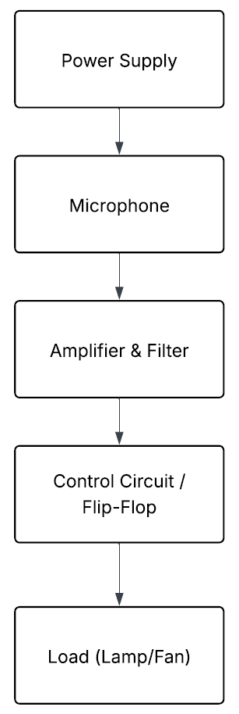
Pinout / Circuit Connection:
- Microphone sensor OUT → Arduino digital pin 2
- VCC/GND → Arduino 5V and GND
Components Required:
- Arduino UNO
- Microphone sound sensor module
- Breadboard
- Led
- Power supply
- Jumper wires
Working Principle:
The microphone sensor detects the sound of a clap and converts it into a voltage signal. The Arduino reads this signal, and when it crosses a threshold, it toggles the output pin connected to the relay. The relay then switches the appliance ON or OFF. A simple transistor circuit can also achieve the same effect without programming.
Operation (Step-by-Step):
- Connect microphone sensor to Arduino input.
- Connect relay module to digital output.
- Upload clap switch code.
- Clap near the sensor → appliance toggles ON/OFF.
Code:
int micPin = 8; // Microphone module digital output
int ledPin = 13; // LED pin
bool ledState = false; // To remember LED ON/OFF state

void setup() {
pinMode(micPin, INPUT);
pinMode(ledPin, OUTPUT);
Serial.begin(9600);
}

void loop() {

int micValue = digitalRead(micPin);

// Microphone module gives HIGH on clap
if (micValue == HIGH) {
ledState = !ledState; // Toggle LED state
digitalWrite(ledPin, ledState);
delay(300); // Debounce delay so single clap doesn't toggle multiple times
}
}Conclusion:
The Clap Switch project demonstrates how sound can be used as a control signal in electronics. It highlights principles of sound sensing, signal conditioning, and relay switching. Such systems are often used in low-cost automation projects for energy saving and convenience.
References:
[1] Arduino Project Hub, “Clap Switch using Arduino,” 2020. [Online]. Available: https://create.arduino.cc/projecthub. [Accessed: Sep. 13, 2025].
[2] S. Monk, “Practical Electronics for Inventors,” 4th ed., McGraw Hill, 2016.

